Desktop Calendar Instructions
Inspired by Rachel Tessman at StampYourArtOut.com
Start with a piece of standard card stock (8 ½” x 11”) in your choice of color. Cut to 5 ½” to 8 ½”, and score on the 8 ½” side at 2 ¼” and 2 ¾”, as shown below.
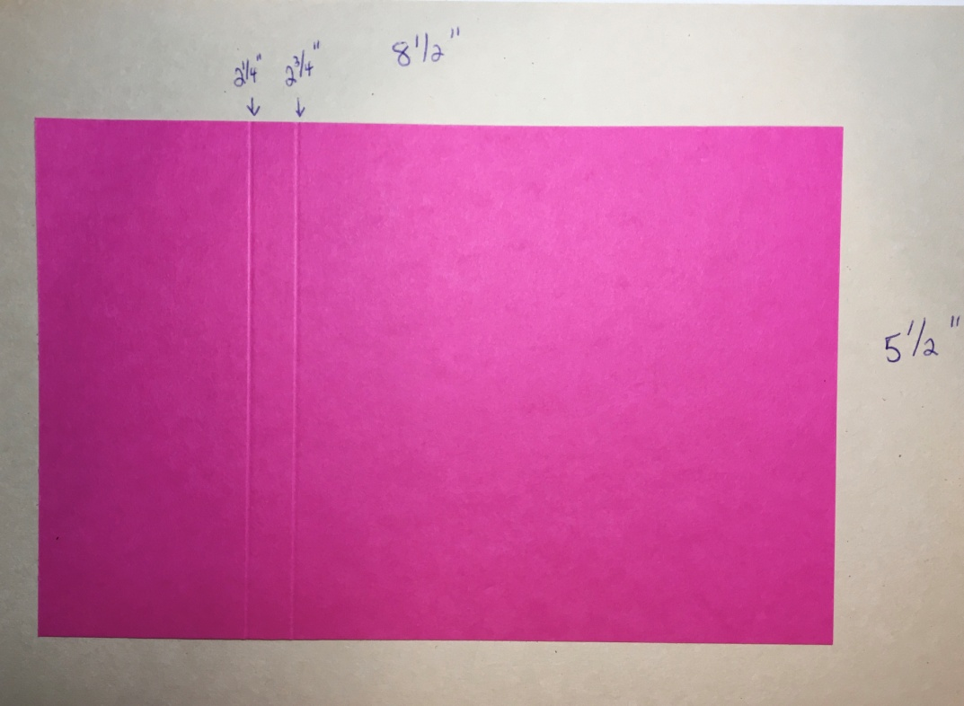
On the same piece of paper, score on the 5 ½” side at 3/8” and 7/8” in from each side, as shown below.
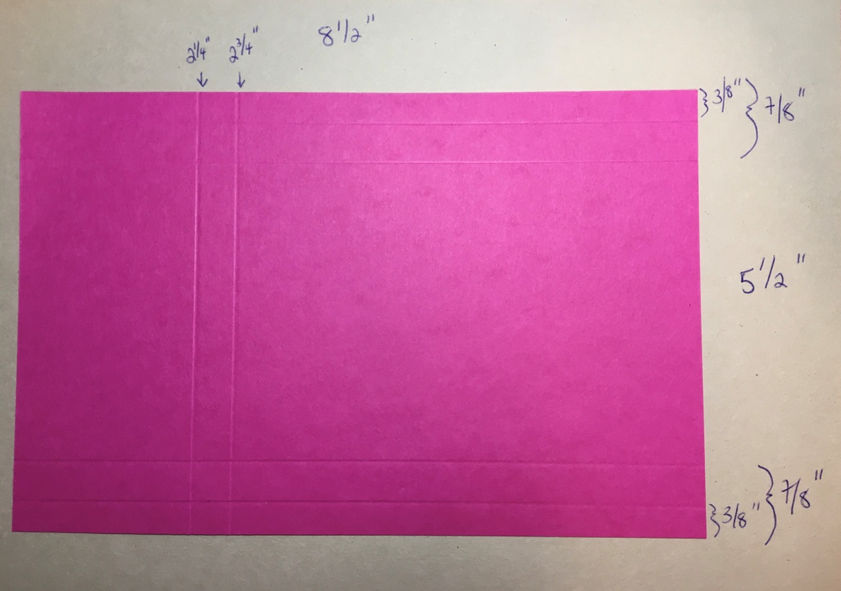

Use your cutting board to cut out the parts shown below. Essentially, use the score line at 7/8” to trim up to the score line at 2 ¾” on both sides of the paper. Then, use your scissors to completely cut away the pieces. See the picture below to visually explain the end result.
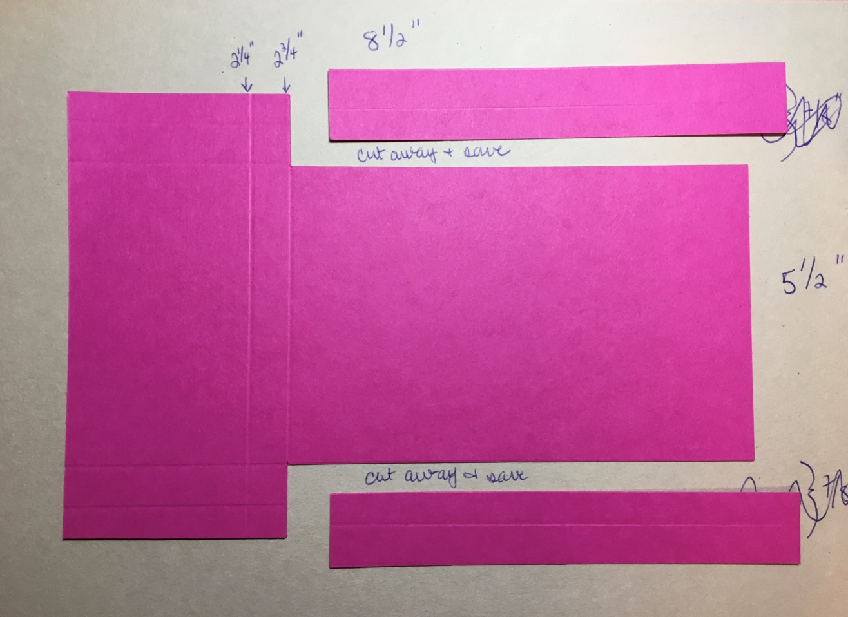
The piece pictured below will be the front of the calendar. It will be used to create the pocket for the Post-It notes and pen. It will also be used to create the area where the calendar will be attached. Cut the 2 ¼” and 2 ¾” score lines at an angle, as shown below. They will be tabs in the pocket.

Get a piece of 6” x 6” DSP or pattern paper that works well with your card stock. Cut this into two pieces. One piece is 3 ½” x 4”, and the other is 3 ½” x 2”.
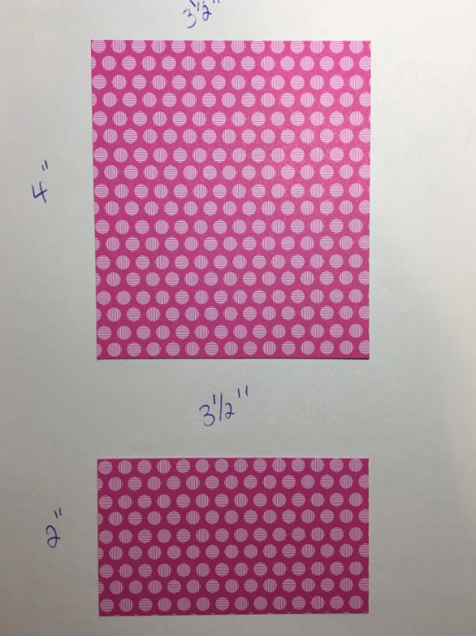
The next steps will outline putting the card front together. The first step is to fold the score lines on the card base. Reference the picture below to make your folds.
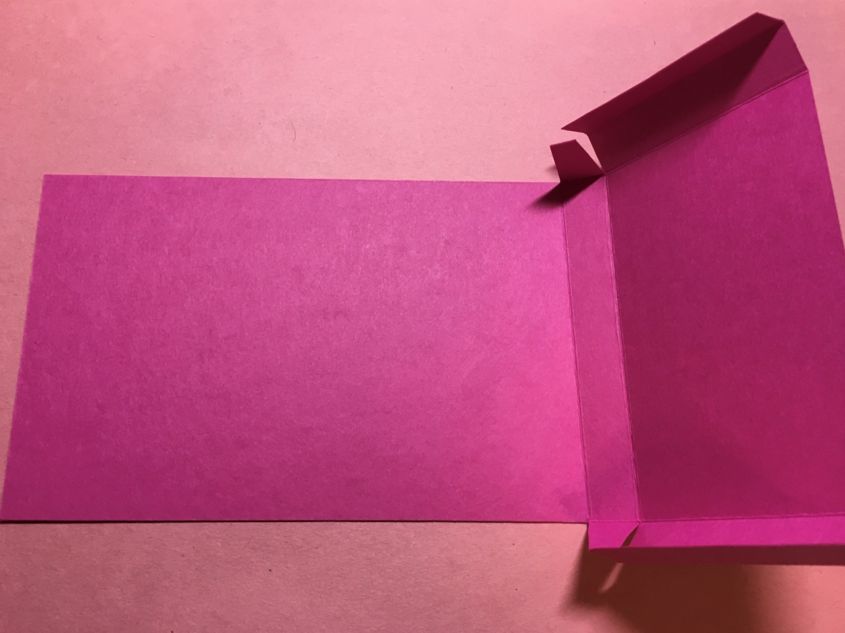

Add your cut DSP pieces to the base. Again, reference the picture below to see where the two pieces are attached.
One will go on the back of the base. The calendar will go on top of this piece of DSP. This is the DSP measuring 3 ½” x 4”.
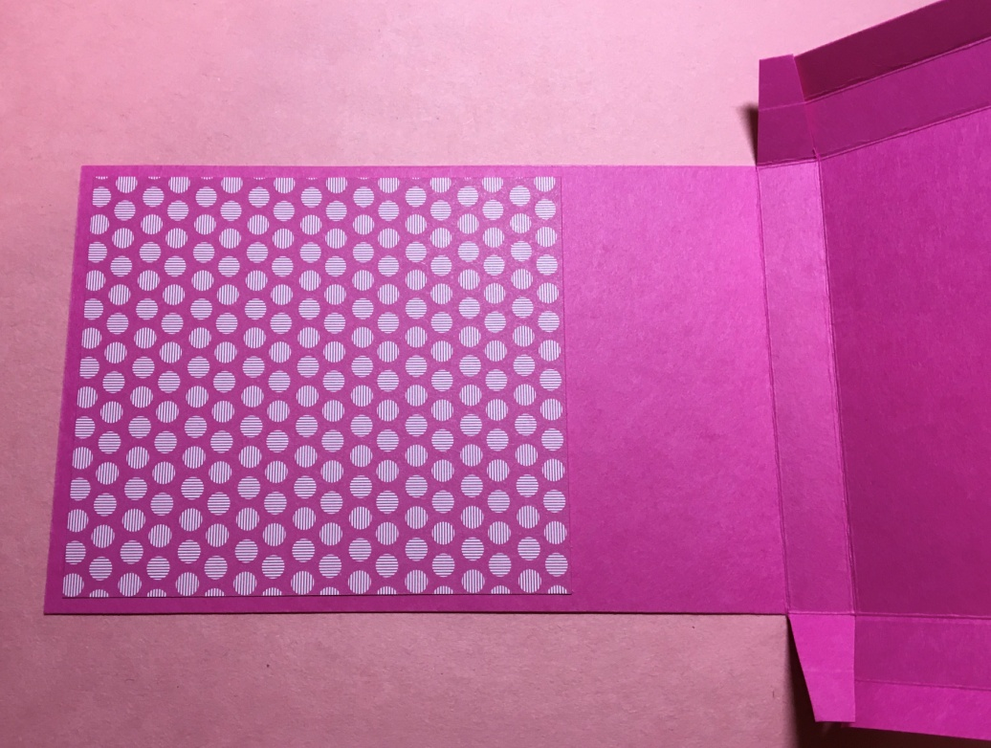
The other will go on the front of the pocket. This is the DSP measuring 3 ½” x 2”. Pay special attention to where this piece is attached. The card stock is essentially folded up to make the pocket.
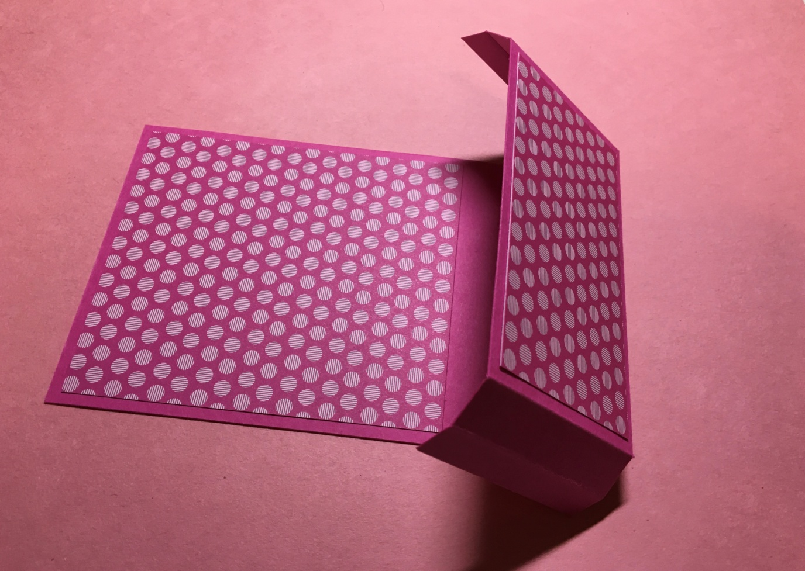

The next step is to cut two pieces of card stock from the “leftover” 5 ½” x 8” piece that you have.
One piece will be 8 ¼” x 3 ¾”. Score it on the 8 ¼” side at ½”, 1 ½”, and 2 ½”. This piece will be the back of your calendar.
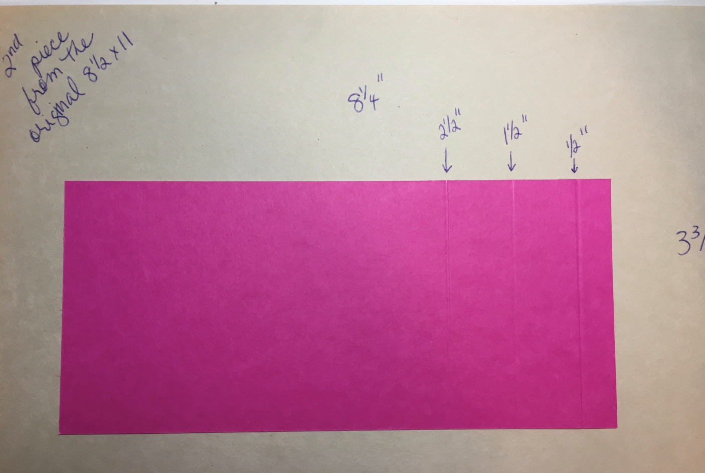
The second piece will be 4 ¼” x 1 ½”. Score this at ½” and 1” on the 4 ¼” side. This will become the pen holder inside the pocket.
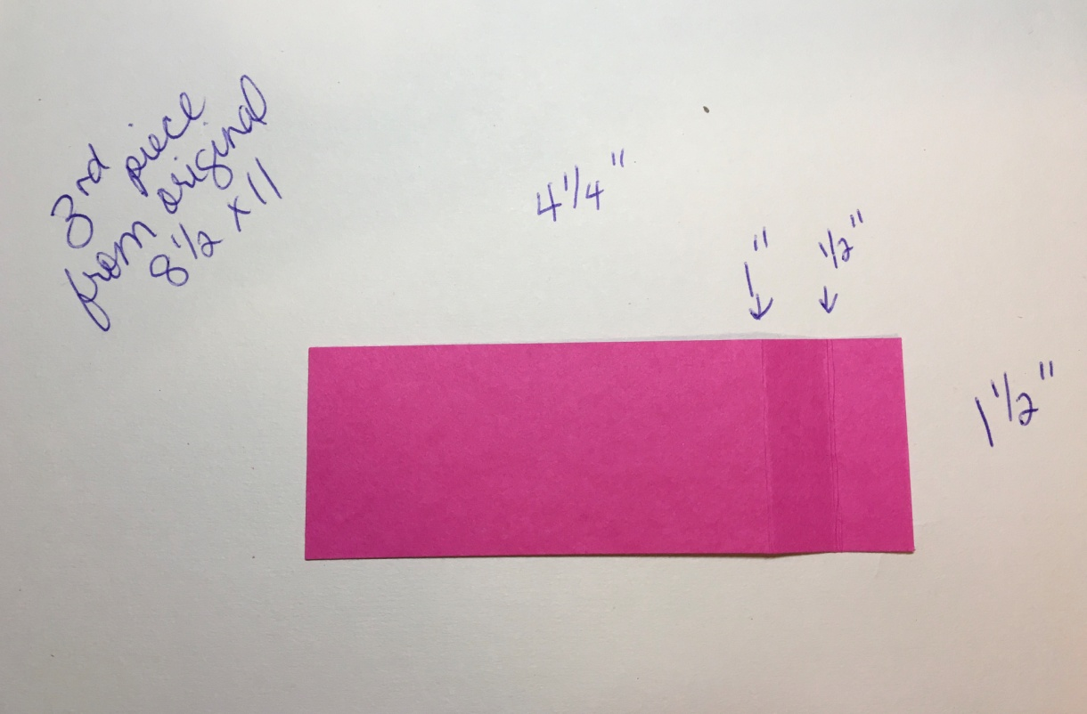

The next step is to attach the pen holder piece before adhering the pocket together.
Fold your pen holder piece as pictured below.
Add adhesive, as pictured below. “Tear and tape” is shown below. You can also use a snail adhesive. A liquid adhesive can be used also but will take longer to set.
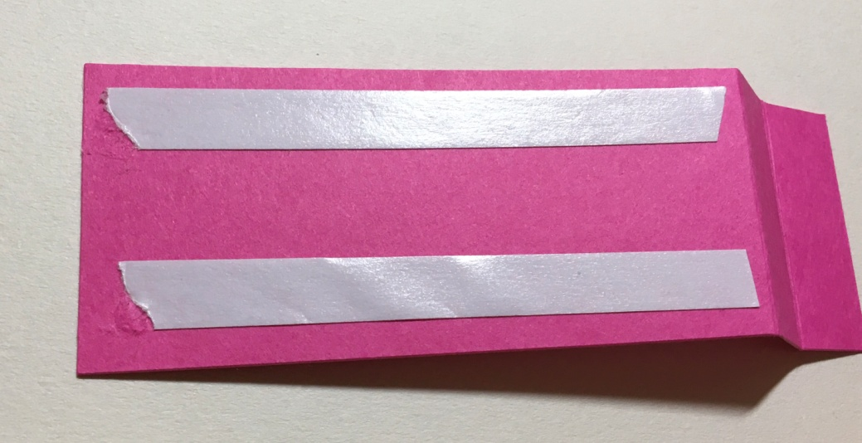

Orient your calendar base so the pocket part is at the top and the large piece of DSP is facing you. Attach the pen holder piece as pictured. The pen holder piece will butt up against the bottom of the large piece of DSP.
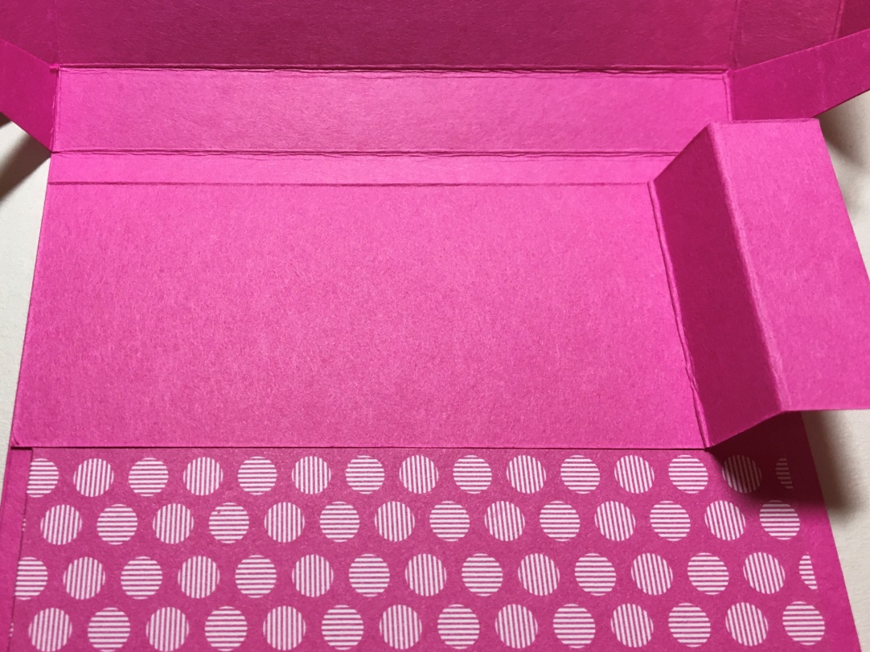
Now, the pocket and the pen holder need to be adhered. Attach some “Tear and Tape” adhesive (or your choice of adhesive) as shown below. The areas where the adhesive is will be attached on the back of the calendar base. The picture below also give another view of where the pen holder is attached.
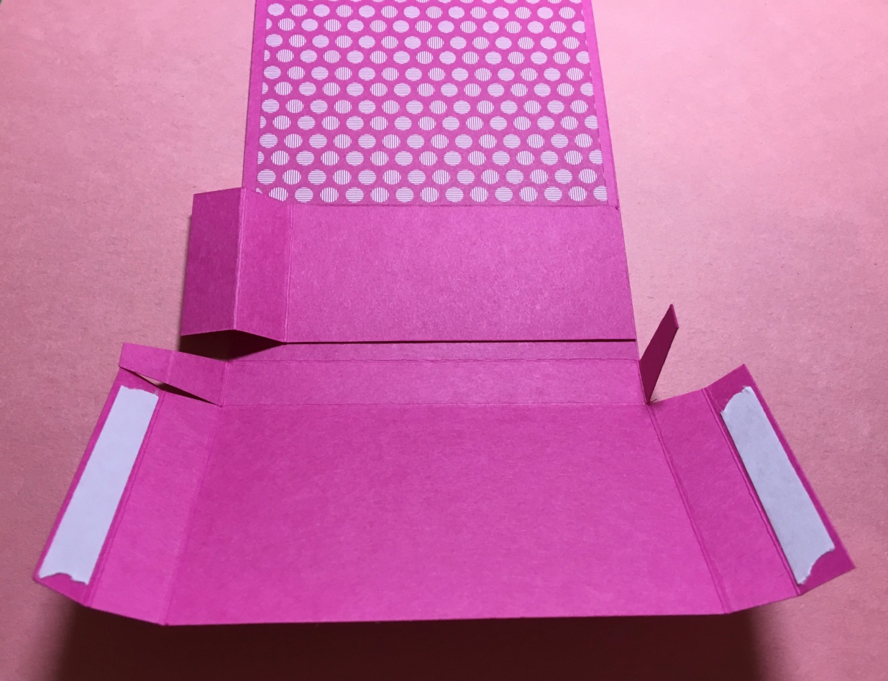

Put some liquid glue on the pen holder piece, as shown below. Place your Post-It note pad where it will be in the pocket. This will give you a little more stability when your adhering the pocket together. Take the tape off the “Tear and Tape”.
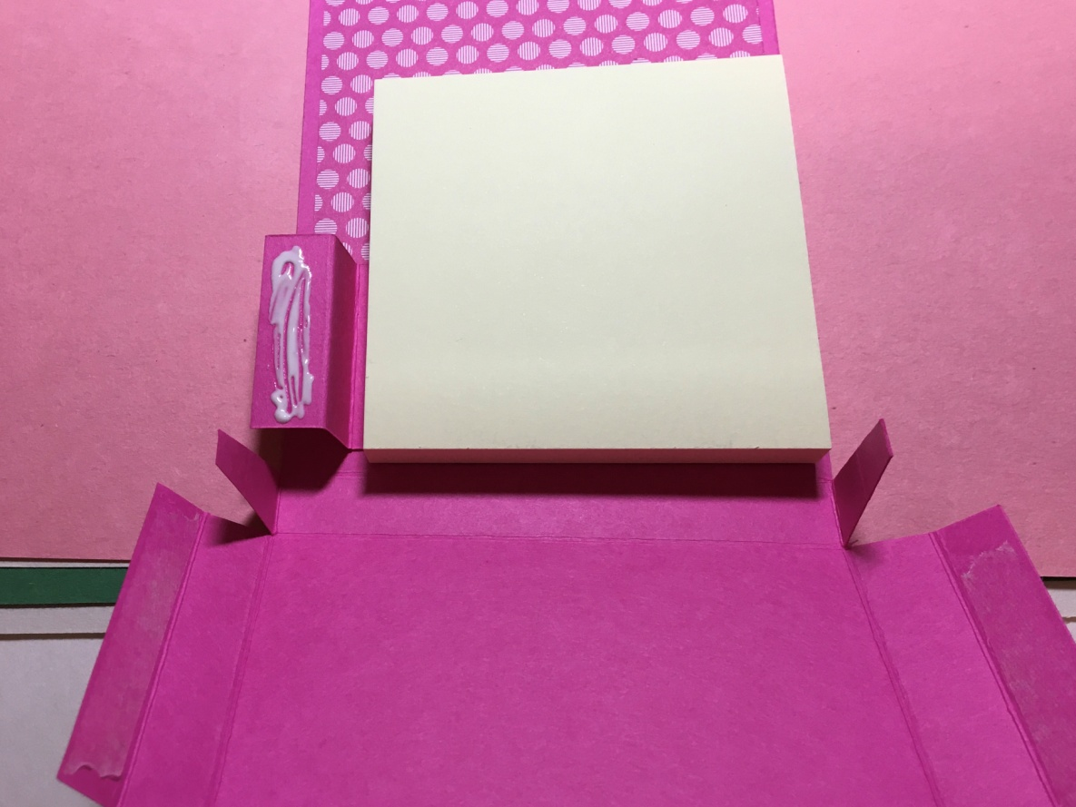
Fold the pocket up while bringing the pocket flaps (the ones where you have the “Tear and Tape”) to the back of the calendar base. Pictured below is the back of the calendar base with the pocket flaps adhered.
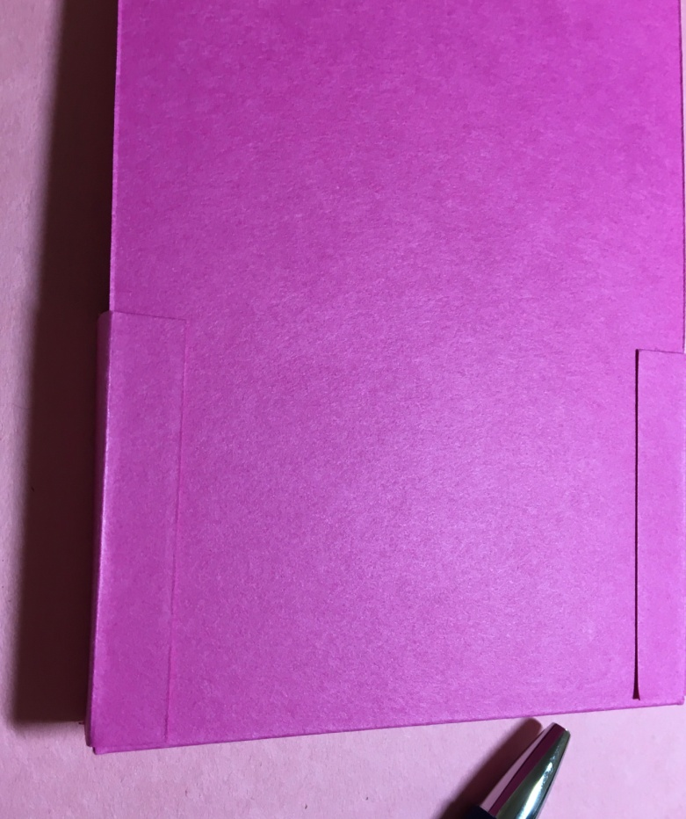
Pictured below (not super easy to see) is the pen holder that has been created inside the pocket. Since you used liquid glue, you should be able to move the pen holder to get it in place, if needed.
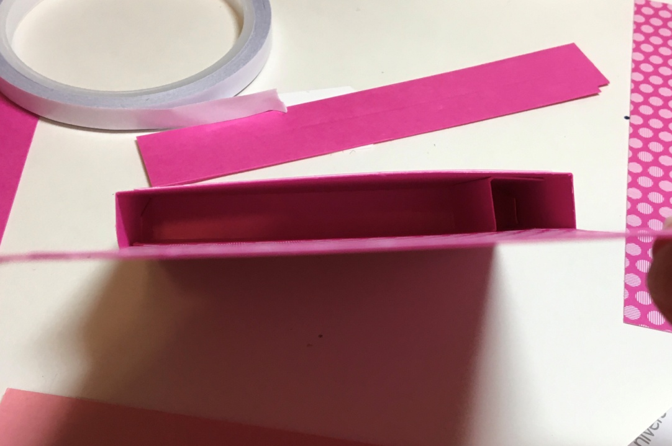
It’s time to put the back together. Get the piece that you cut to 8 ¼” x 3 ¾”, scored at ½”, 1 ½”, and 2 ½”, and fold it as shown below.
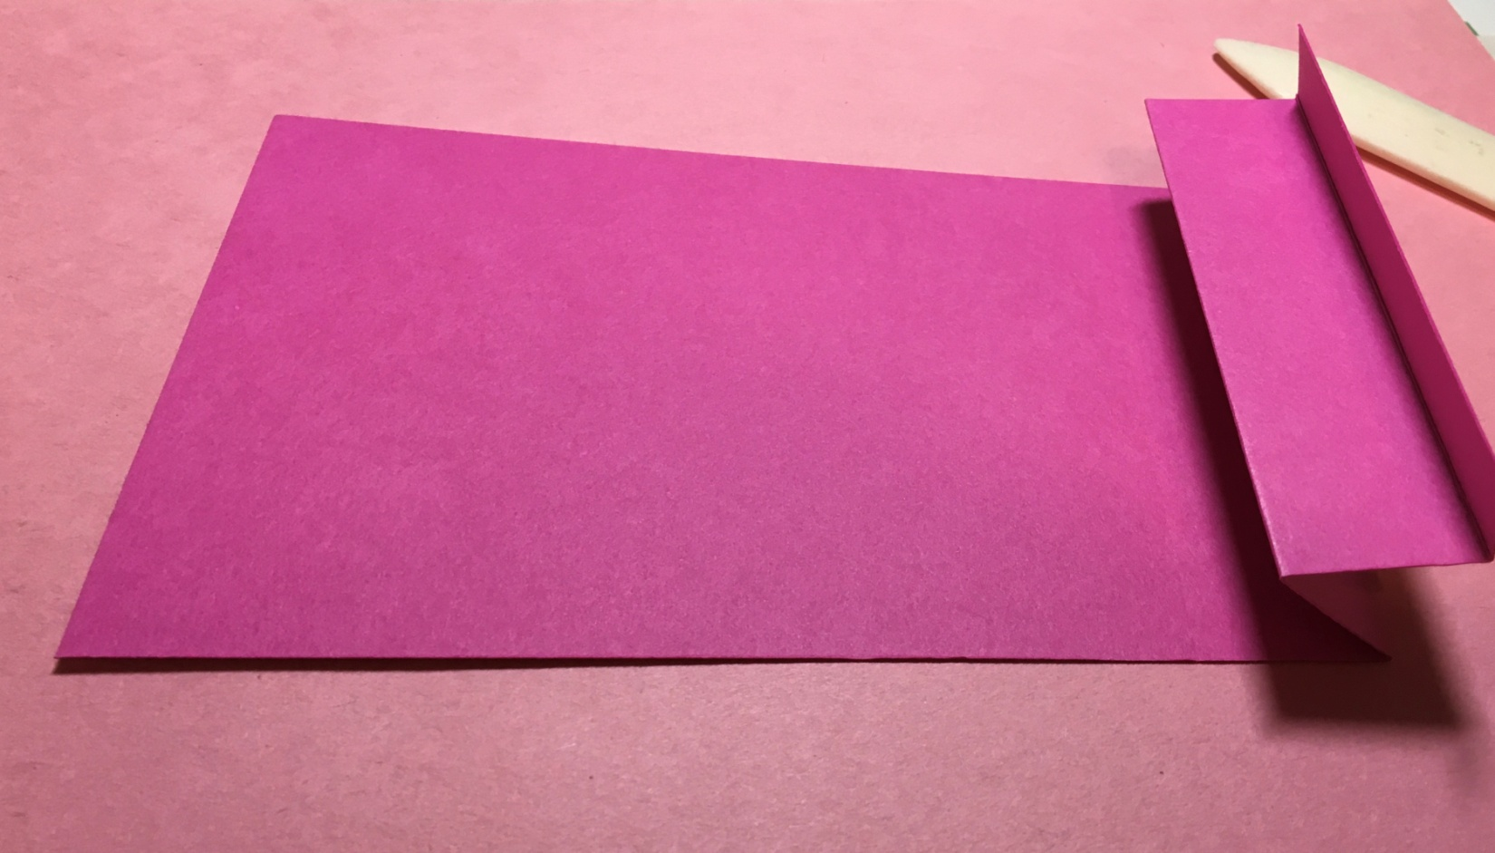

Attach the top of this piece to the front of the calendar. Add a piece of “Tear and Tape” as shown below.
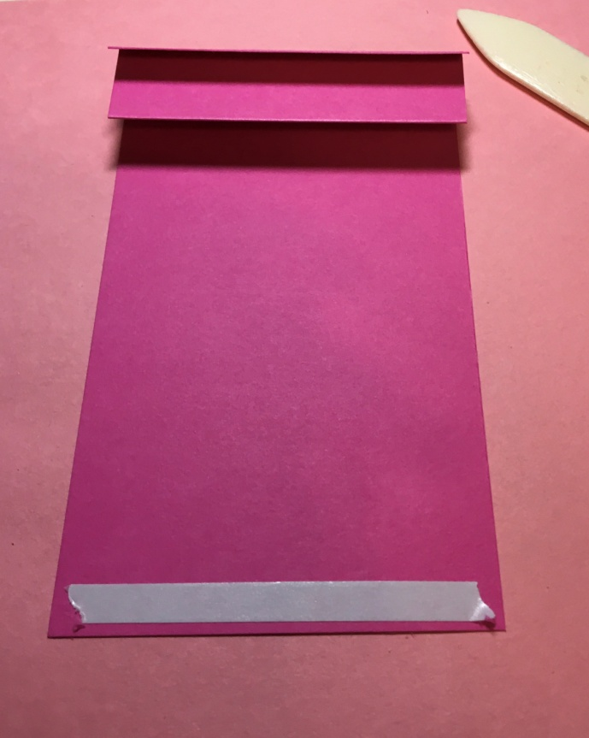
Attach it to the calendar base.
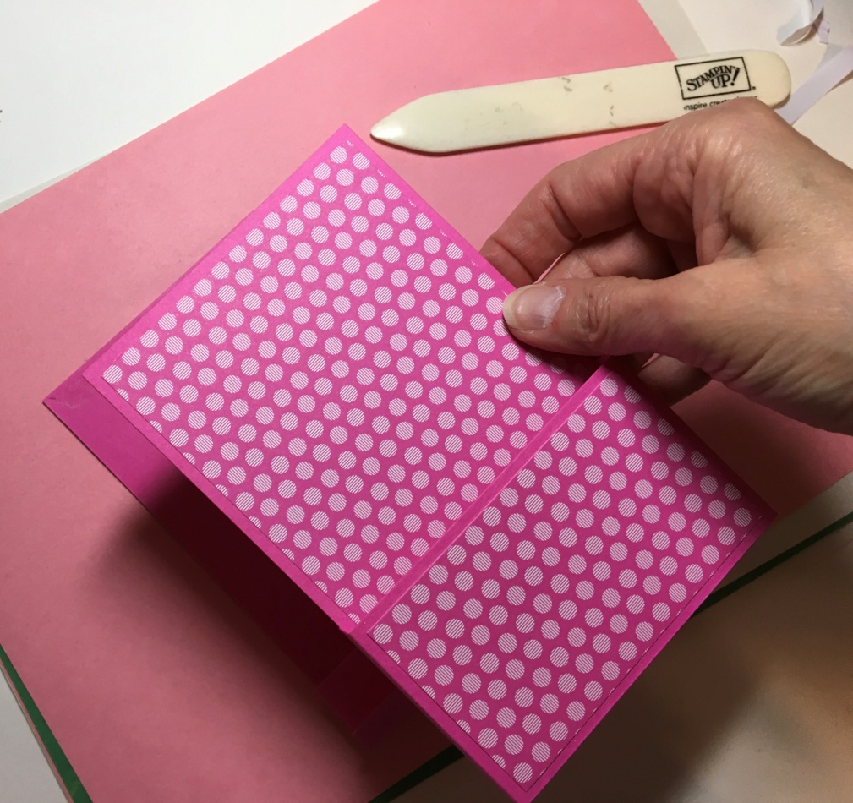

The bottom of the piece will not be attached yet. This is a good time to add any type of ribbon embellishment that you want to the outside of the pocket. I used about 16” of ribbon and tied it around the pocket.
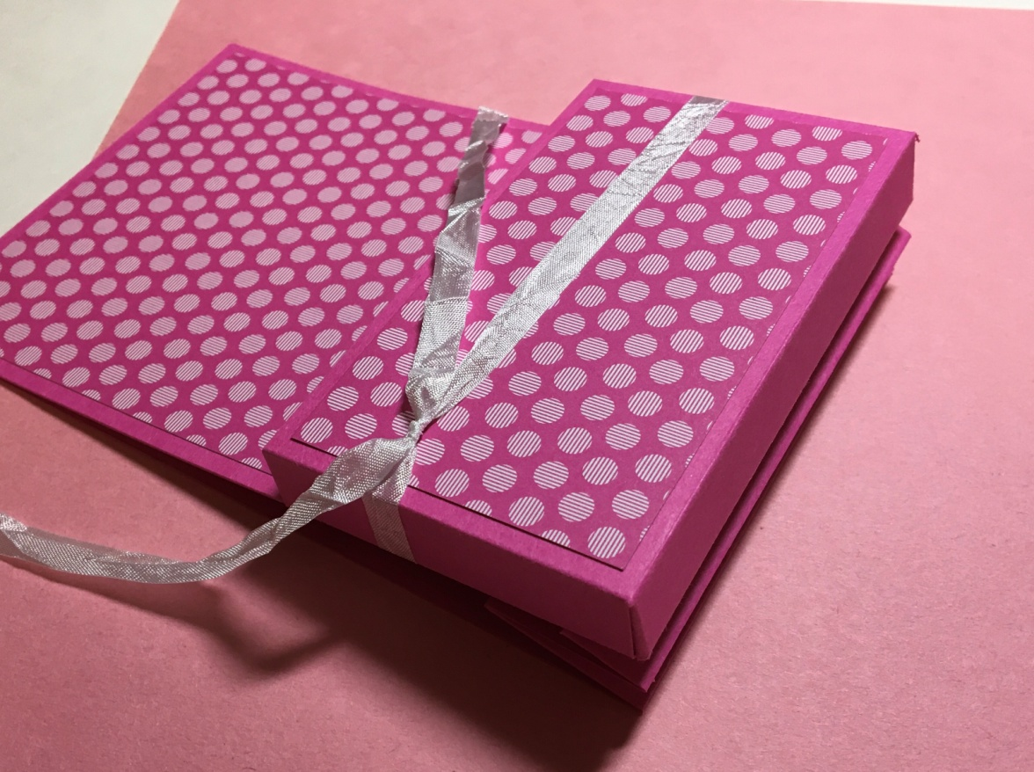
Now, you can attach the bottom of the back of the calendar to the bottom of the pocket. Use “Tear and Tape” to adhere the piece. You should be able to literally lay the front of the calendar onto the back of the calendar to adhere them together.
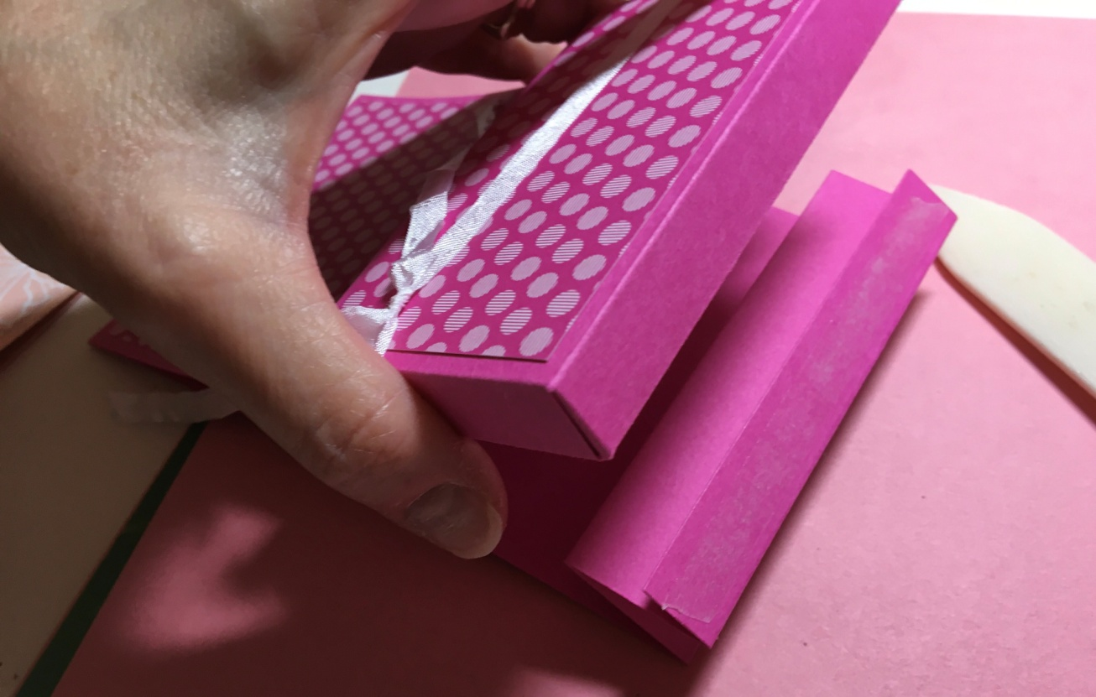

The only thing left is decorating and adding the calendar. Choose what you would like for a sentiment and any other embellishments to finish your project.
